Laboratory 01

Jeffrey Daniel Leiva Cascante
Tamara Nicole Rodríguez Luna
Computer engineering department, Tecnológico de Costa Rica
IC4301 – Databases I
Teacher: Msc. Adriana Álvarez Figueroa.
September 04th 2022.

This image is from the database before lab point 8 was Applied:

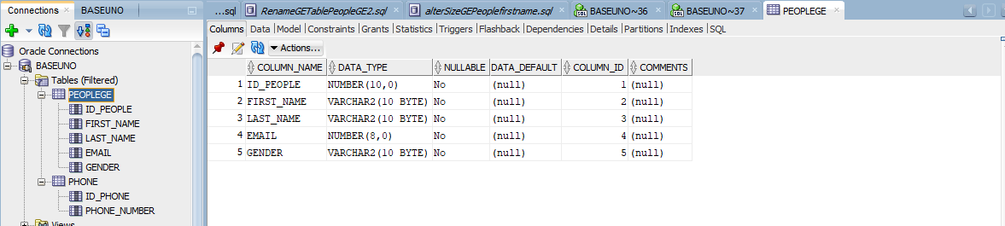
This image is from the database after lab point 8 was Applied:
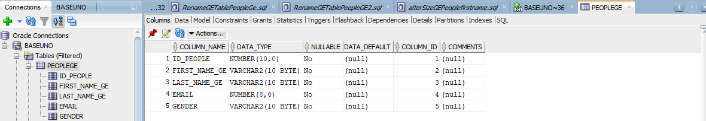
This image is from the database before lab point 9 was Applied:
